Building Background Knowledge of Oedipus the King

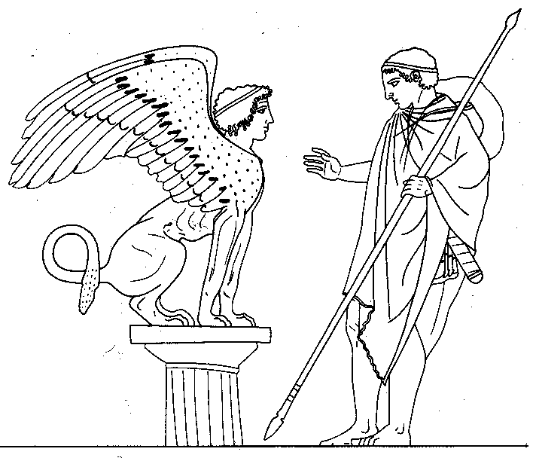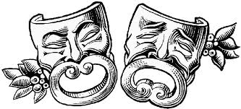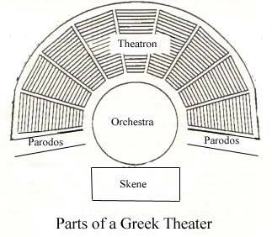

1. Who is the author of Oedipus the King?

Sophocles.

2. The author of Oedipus the King lived in Athens, Greece from 496 to 406 B.C.

3. What is a tragedy? Provide an example.

A tragedy usually includes a noble and important person as their protagonist that gets caught up in an unsolvable dilemma. These protagonists have a hamartia, or tragic flaw, that is the cause of their downfall. Their punishment is often far worse than their mistake. Oedipus Rex and Medea are examples of tragedies.

4. What is a tragic hero? Give an example of a past or modern day tragic hero.

A tragic hero is a character that is noble and important who is imperfect and falls because of it. Their tragic flaw or mistake (hamartia) causes a disproportionate consequence.

Jason of Medea is a tragic hero who loses his wife, children and power due to his break up to Medea.

5. Explain what a tragic flaw is and provide an example.

A tragic flaw is a weakness of the tragic hero that causes their downfall. Jason’s decision of breaking up with Medea proved catastrophic.

6. How were Greek tragedies performed?
These tragedies were often performed in outdoor theaters, during religious (The Lenaea Ceremony and the Great Dionysius Ceremony) celebrations commemorating the wine and goat god, Dionysius. They usually ended with catharsis, or cleansing, of negative emotions.

7. Provide a definition of theme and explain its significance in a story.
A theme is a unifying idea woven into the story, evident in the characters’ actions and fate.

8. Define imagery and explain its role in a story.

Imagery is when the author uses objects that are not literally there, but provide a comparison to the situation in order to further understanding. Imagery often appeals to the five senses, and is extremely useful when expressing difficult concepts and plots in a story.

9. What is foreshadowing and what effect does it have?

Foreshadowing is a dramatic device that hints a darker future in a vague, ominous manner. It gives the audience a sense of doom and direction for the story.

10. What is the riddle of the Sphinx and what is the answer to this riddle?

“What walks on four feet in the morning, two at noon and three in the evening?” Humans.

11. What role does the chorus play in a Greek tragedy?

They usually act as a sort of narrator, bring on an additional, more socio-religious viewpoint.

12. What does the name Oedipus mean?

Swollen foot.

Define the following terms:

Climax – Most intense part of the story.

Dialogue – The spoken text in a play, the conversations between characters.

Acts – Subdivision between parts of a play.

Scenes – Scenes divide an act into sections.

Stage directions – Directions from the director to the actors.

Sets – Artificial settings for a play/movie etc.

Props – Furnishings, set aspects both big and small that add to the story.

Monologue – Speech delivered by one person.

Soliloquy – Person talking to themselves, providing insight for the audience about the character’s feelings and thoughts.

Aside – Words spoken by an actor, addressed to the audience and only to the audience. (Message not intended to other characters.)

